https://www.metinfo.cn/download/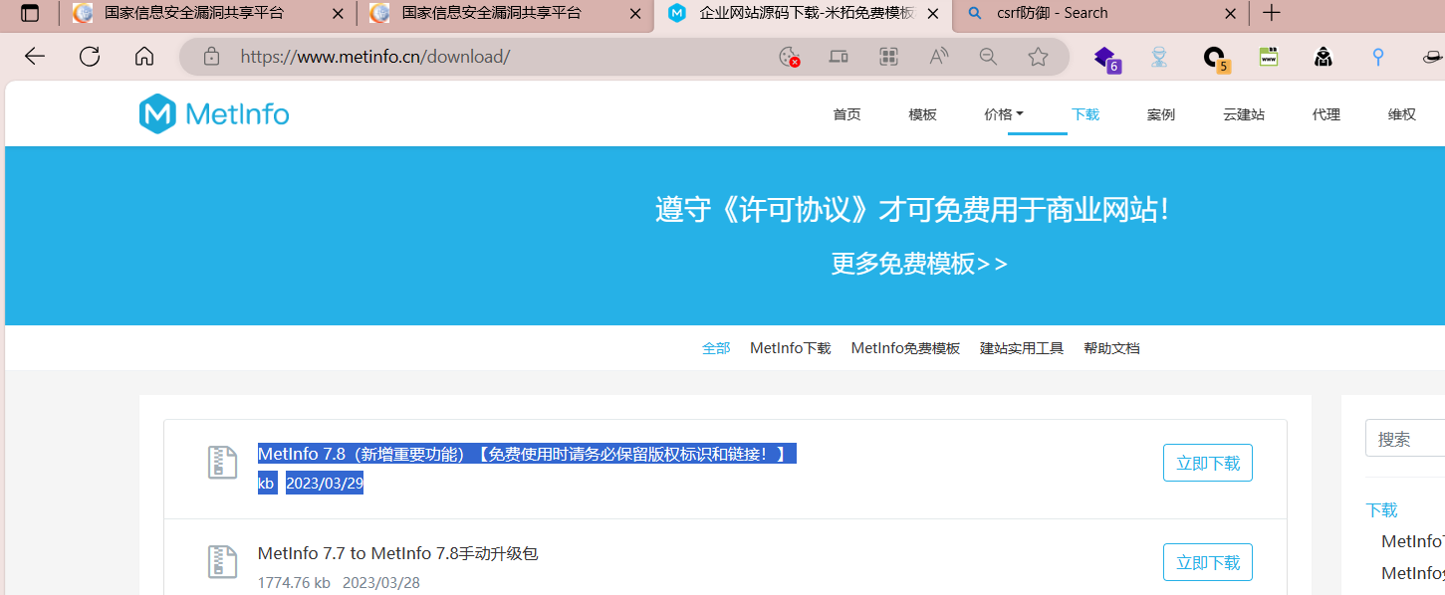

app\app\met_template\admin\index.class.php The file only determines whether the operation is done with the permission of admin, and there is no judgment on dodelete()

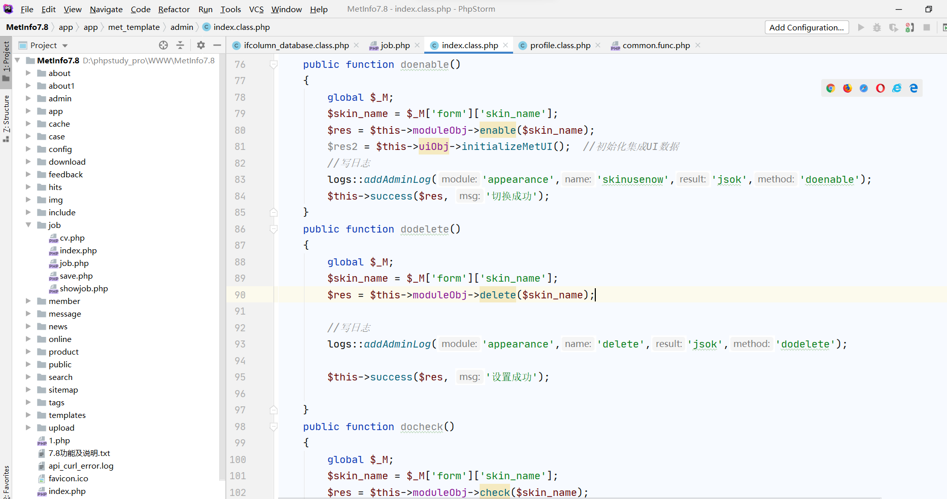

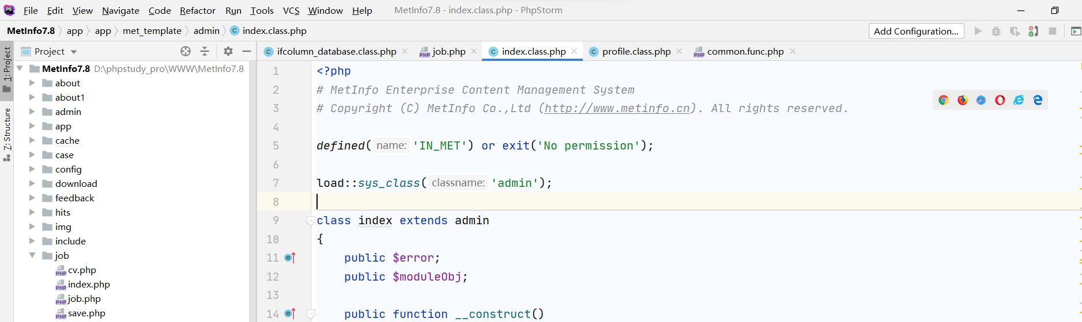

Test1 id is 10, password 123456

Test2 id is 11, password 123456

Test3 id is 12, password 123456

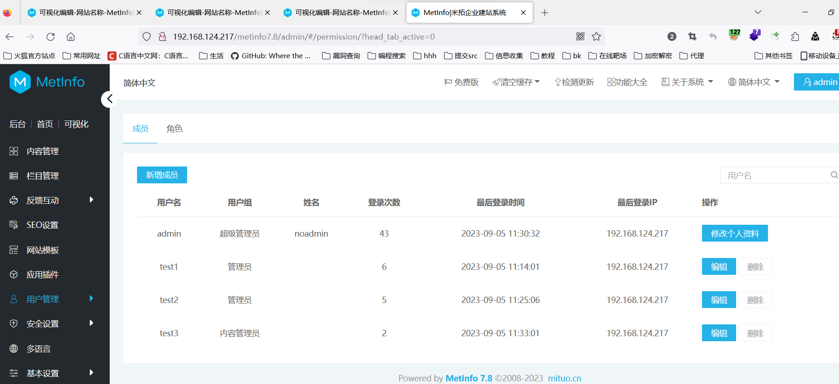

When clicking to confirm deletion, capture the packet and send it to the built-in csrf generation module of BP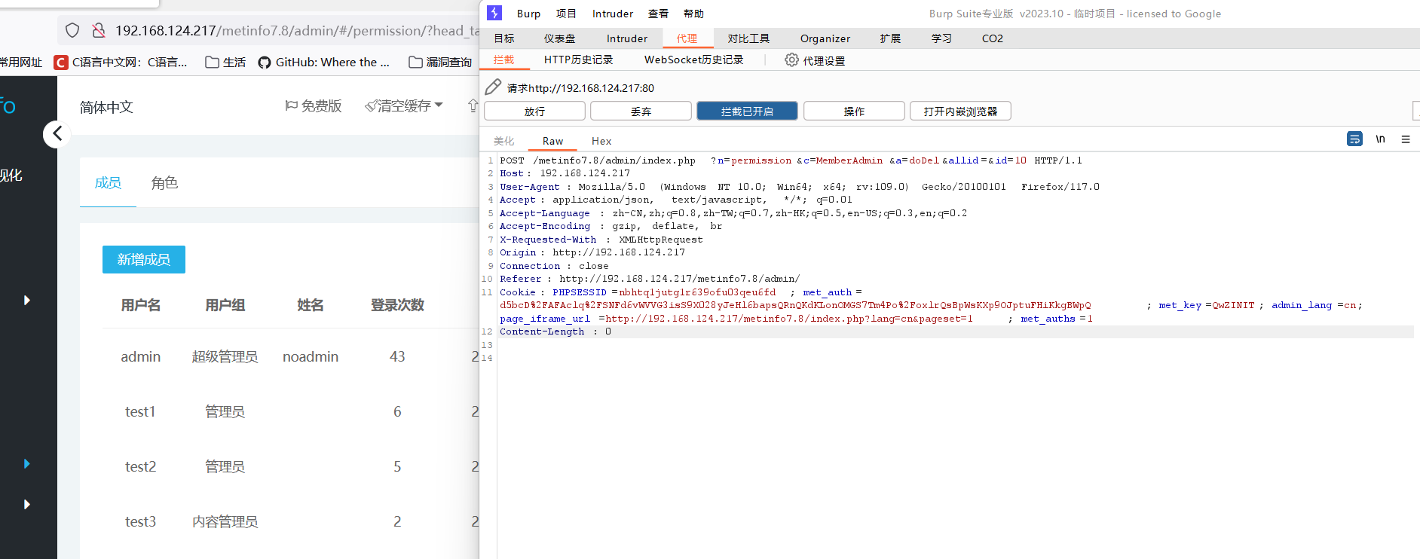

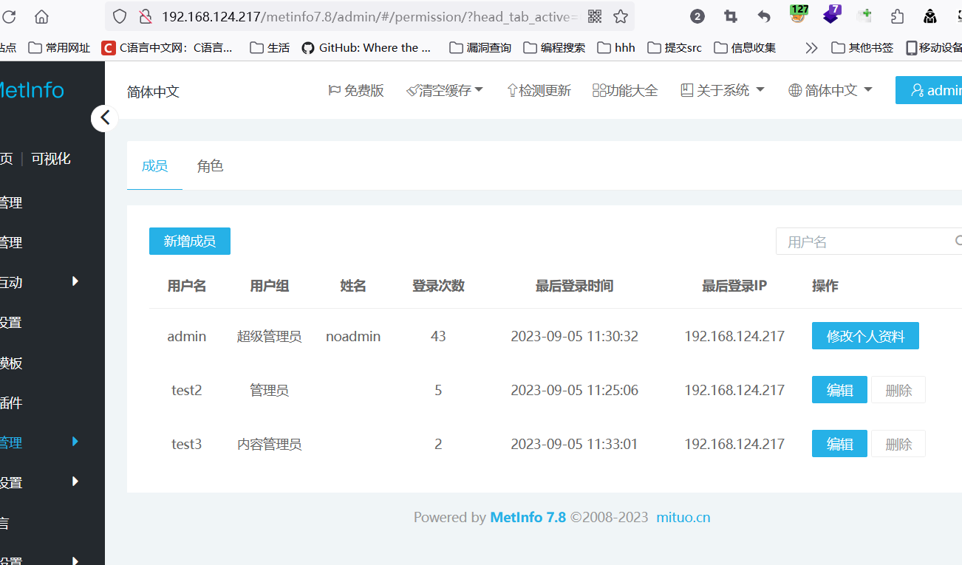

Direct access

http://192.168.124.217/metinfo7.8/admin/index.php?n=permission&c=MemberAdmin&a=doDel&allid=&id=11 ID 11 is test2

Change the browser and log in to admin, then access the link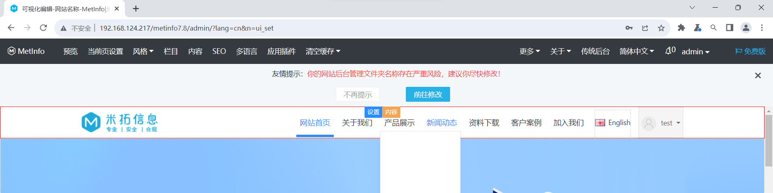

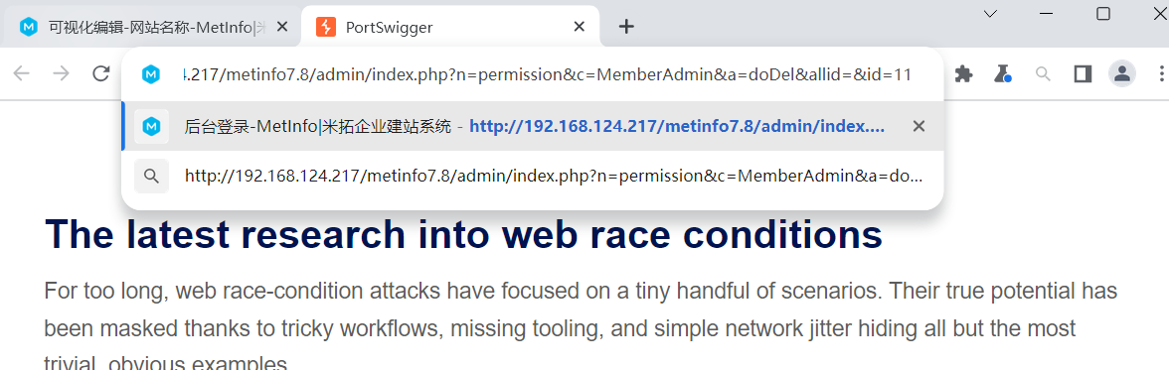

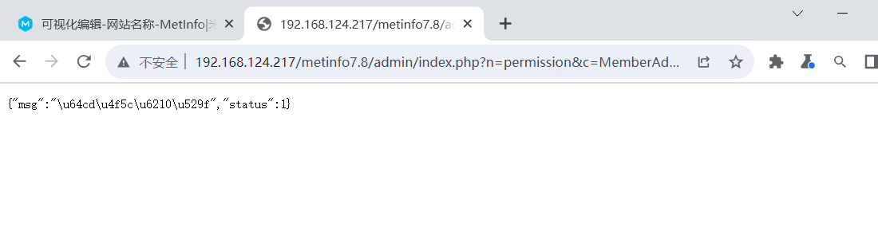

Test2 (id=11) deleted successfully

ID changed to 12 (test3) bp generated by the csrf module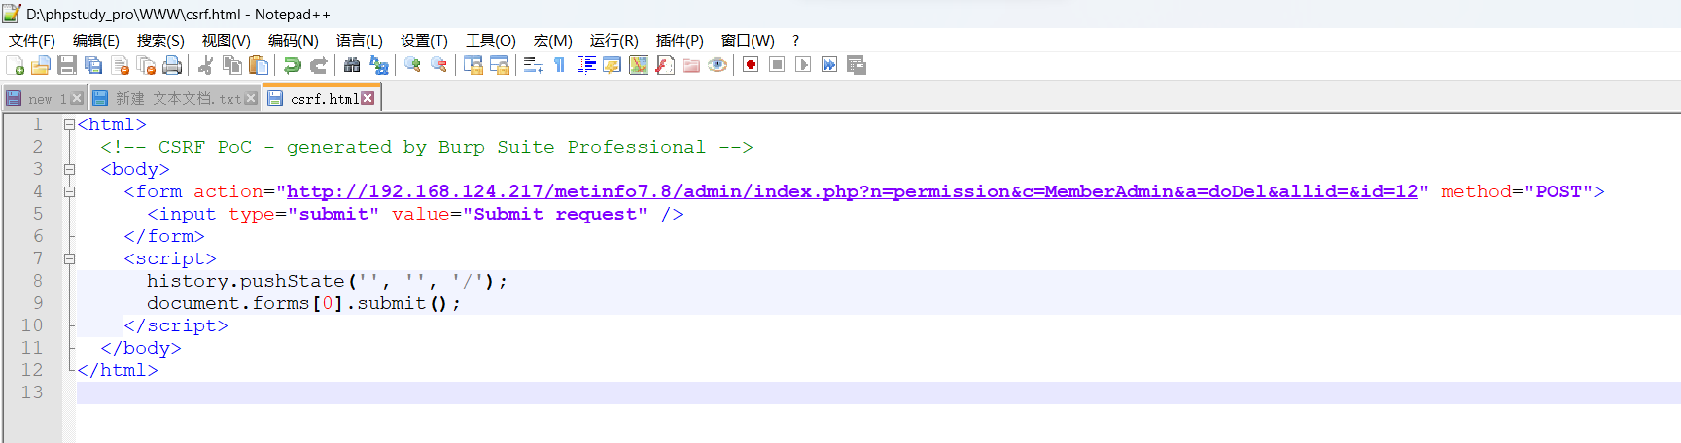



Admin access <http://192.168.124.217/csrf.html>



